Sink Hole Attack in AODV

**Software:** NetSim Standard v14.0, Visual Studio 2022

**Project Download Link:**

Follow the instructions specified in the following link to download and setup the Project in NetSim:

https://support.tetcos.com/en/support/solutions/articles/14000128666-downloading-and-setting-up-netsim-file-exchange-projects

**Introduction:**

Sinkhole attack is one of the most severe attacks in wireless Ad hoc networks. In sinkhole Attack, a compromised node or malicious node advertises wrong routing information to pretend itself as a specific node and receives whole network traffic. After receiving the whole network traffic, it can either modify the packet information or drop them to make the network complicated. Sinkhole attacks affect the performance of Ad hoc network protocols such as the AODV protocol.

**Real-World Context:**

In a real-world scenario, a small ad-hoc network consist of a few laptops and mobile devices wirelessly connected to each other. When one node in this network is malicious, the impact can be significant.

Figure 1: Real world scenario for Sink Hole Attack in MANET using AODV

**Sinkhole Attack Overview:**

* The Malicious nodes **(Attacker)** enters the network and starts intercepting and diverting network traffic.
* When **Laptop-User-1** attempts to communicate with **Laptop-User-3** the Malicious Node **(Attacker)**intercepts the communication by responding to route requests and diverting data packets.
* As a result, the data that **Laptop-User-1** intended for **Laptop-User-3** gets redirected to the Malicious Node **(Attacker)**. This could be sensitive information, files, or any data being exchanged.
* **The Malicious Node (Attacker) intentionally discards all incoming data packets, thereby effectively preventing the data from reaching its intended destination.**

**NetSim's Role:**

We use NetSim to simulate and analyze sinkhole attacks, aiding in the understanding of security vulnerabilities. NetSim offers us the means to replicate real-world scenarios within a controlled, virtual environment.

This document will provide a comprehensive overview of our project's objectives for studying the sinkhole attacks.

**Implementation in AODV:**

* In AODV Source broadcasts the RREQ packet during Route Discovery.
* The destination on receiving the RREQ packet replies with an RREP packet containing the route to reach the destination.
* But Intermediate nodes can also send RREP packets to the source if they have a route to the destination in their route cache.
* Using this as an advantage the malicious node adds a fake route entry into its route cache with the destination node as its next hop.
* On receiving the RREQ packet from the source the malicious node sends a fake RREP packet with the fake route.
* The source node on receiving this fake RREP packet observes this as a better route to the destination.
* All the Network Traffic is attracted toward the Sinkhole (Malicious Node), and it can either modify the packet Information or simply drop the packet.

A file **malicious.c** is added to the AODV project which contains the following functions:

* **fn_NetSim_AODV_MaliciousNode();** //This function is used to identify whether a current device is malicious or not in order to establish malicious behavior.
* **fn_NetSim_AODV_MaliciousRouteAddToCache();** //This function is used to add a fake route entry into the route cache of the malicious device with its next hop as the destination.
* **fn_NetSim_AODV_MaliciousProcessSourceRouteOption();** //This function is used to drop the received packets if the device is malicious, instead of forwarding the packet to the next hop.

You can set any device as malicious node, and you can have more than one malicious node in a scenario. Device ids of malicious nodes can be set inside the **fn_NetSim_AODV_MaliciousNode()** function.

**Steps to simulate:**

1. Open the Source codes in Visual Studio by going to Your work in the home screen of NetSim

-> Source Code and click on the Open code.

1. Expand the AODV project and open the Malicious.c file and set the malicious node id.A screenshot of a computer program

   Description automatically generated

Figure 2: Set Malicious Node in malicious .c file

1. Now right-click on the AODV project and rebuild it.

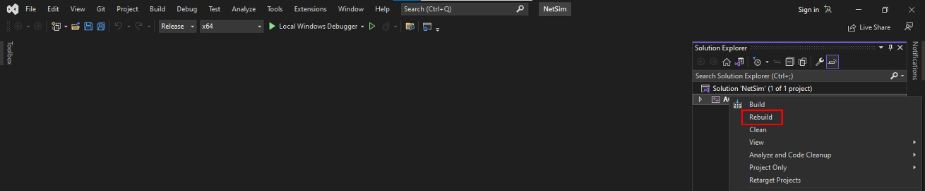

Figure 3: Screenshot of NetSim project source code in Visual Studio

1. Upon rebuilding, libAODV.dll will automatically get updated in the respective bin folder of the current workspace.

**Example:**

1. The **Sinkhole-Attack-in-AODV-Workspace** comes with a sample network configuration that is already saved. To open this example, go to Your work in the home screen of NetSim and click on the **Sinkhole-Attack-in-AODV-Example** from the list of experiments.
2. The network consists of 7 wireless nodes with the properties configured as shown below:

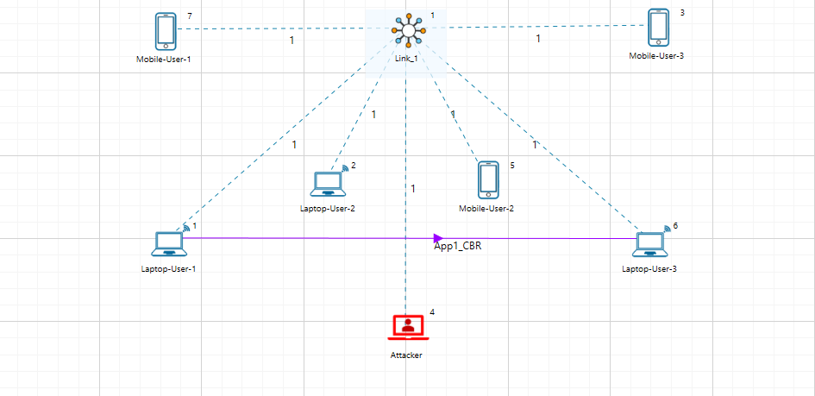

Figure 4: Network Topology

1. Set the Application properties.

|  |  |
| --- | --- |
| Application Properties | |
| Source ID | **1** |
| Destination ID | **6** |

Table 1: Application Properties

1. In the Link Set the Channel Characteristics: **Pathloss only**, Path Loss Model: **Log Distance**, Path Loss Exponent: **3**
2. Run the Simulation for 100 seconds.

**Results and discussion:**

In the packet trace, we illustrate the impact of a malicious node within the MANET, showcasing how it disrupts the normal data transfer process:

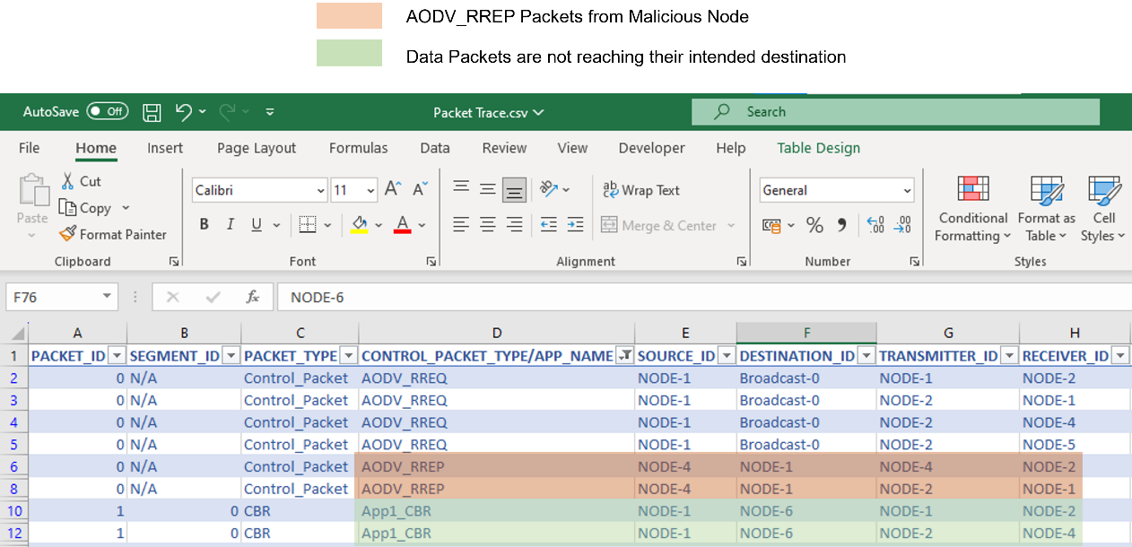

Figure 5: Analysis of results using packet trace

* From the above screenshot ,You will find that the malicious node which is Node-4 gives **AODV_RREP** Route Reply on receiving Route Request **AODV_RREQ** and attracts packets towards it.
* While Node-4 (the malicious node) tries to send a Route Reply **AODV_RREP**, the legitimate destination, Node-6, also attempts to reply, **AODV_RREP** Packets. However, Node-4's **AODV_RREP** reply is favored because it pretends to be the next node is the destination, even though Node-6 is the real destination.
* Because the malicious Node-4 tries to mislead the network by pretending to be a closer destination compared to route reply sent by the actual destination
* You will also find that whatever the Data packets generated from Node-1 are not forwarded

by the Malicious Node-4.

This will have a direct impact on the Application Throughput which can be observed in the Application Metrics table present in the NetSim Simulation Results window. The throughput for Application 1 registers as zero due to the presence of a malicious node (device ID 4) in the network. This node intentionally drops all data packets instead of transmitting them to their intended destination.

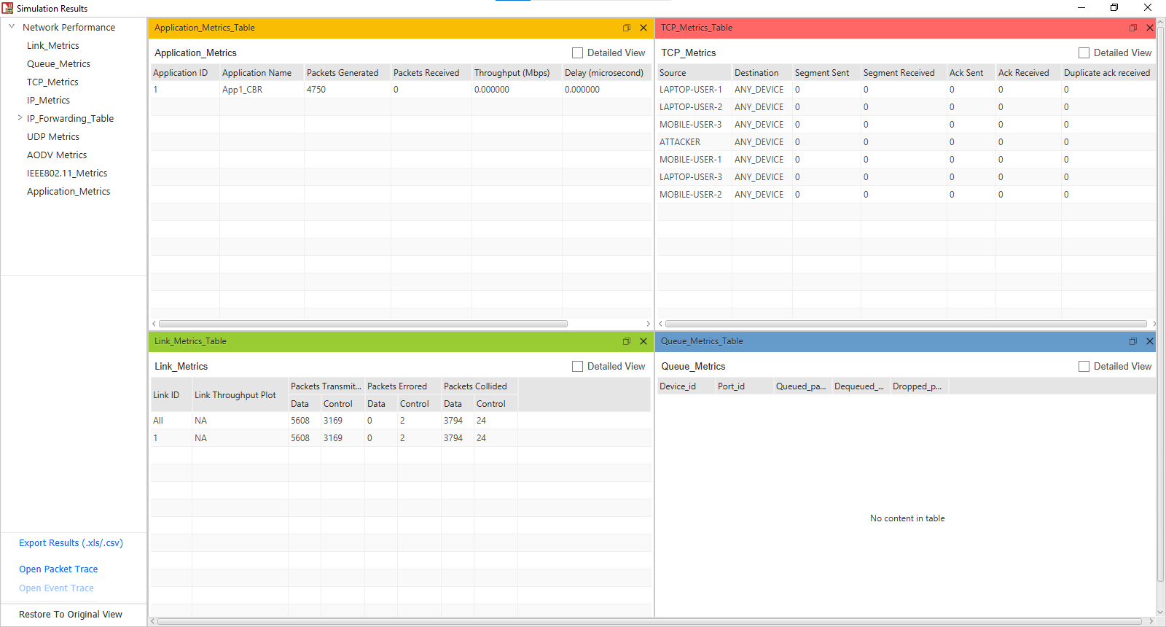

Figure 6: Result Dashboard